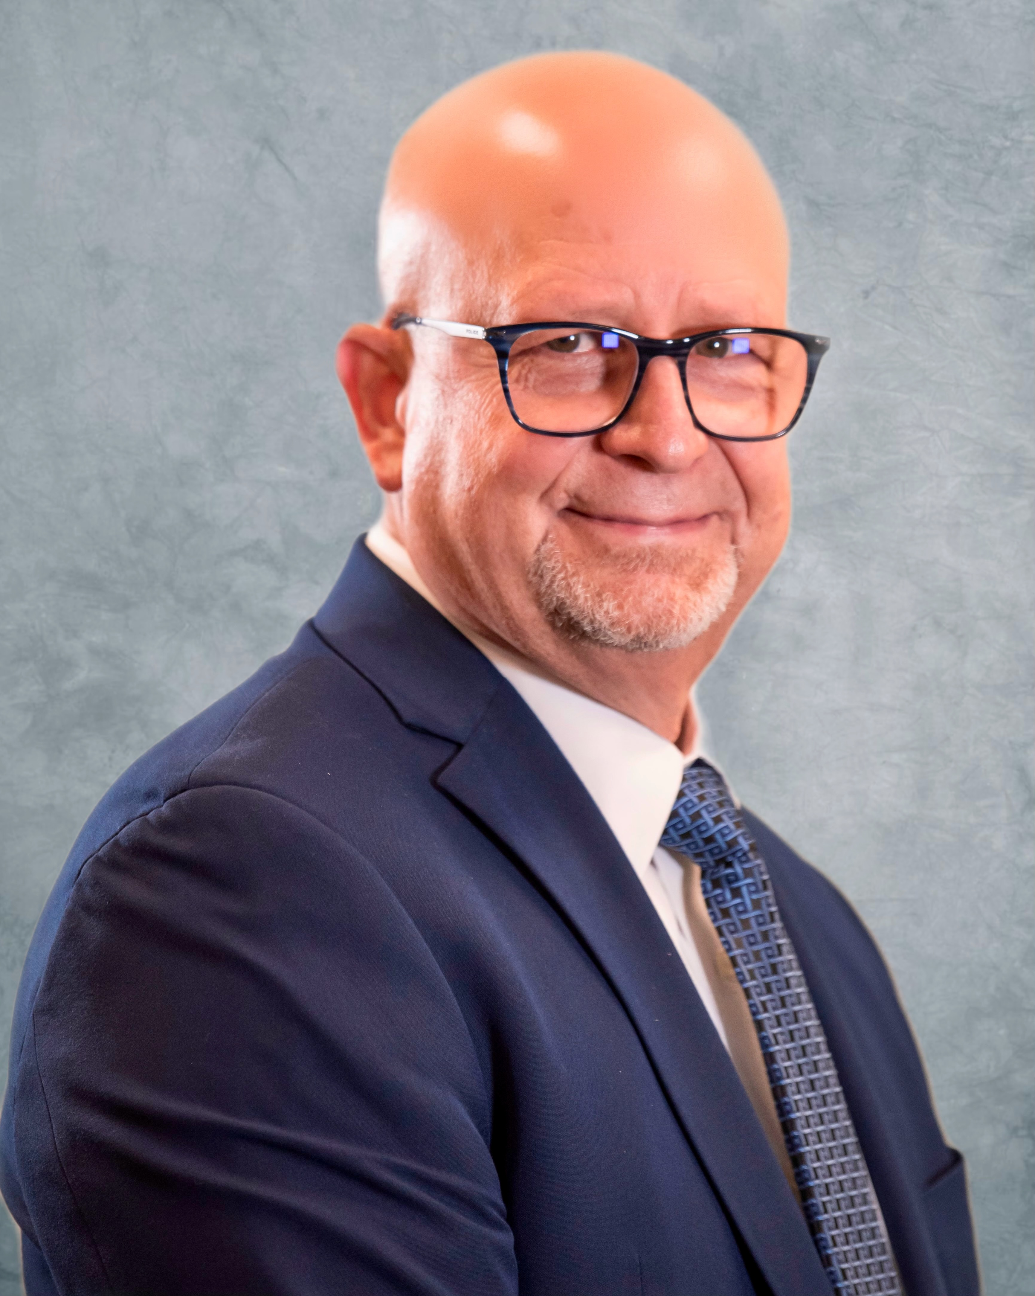

Curriculum Vitae
Dr. Richard J. Stride, Psy.D., MBA, LPC, LMHC

Lacey Washington, 98513

Tel: 360-388-7222
e-mail: docrs62@drstrideforensic.com
Web: www.drstrideforensic.com

Summary of Expertise

26 years’ experience in mental health, substance use disorder, child custody, trainer, conference speaker, and writer. 16 years as a community mental health director and administrator. President & Chief Executive Officer – Community Mental Health Center, Washington. In my capacity as CEO, adept at public speaking, community relations, legislative and regulatory issues, working with Non-profit Boards. Clinical Director/Internal Operations Director for two public mental health centers in the eastern, Washington area. Supervised clinical staff, worked with senior leadership concerning fiscal responsibilities for agency operations.

Clinical skills include Psychotherapy, Hypnotherapy, psychological testing, behavioral analysis, diagnosis, forensic evaluations. Special interest in Intellectually Disabled, and Geriatric clients, brief and long-term counseling (group and individual) adults, adolescents, children and/or families, involving issues of marital relationships, past and present physical/ emotional / sexual abuse, and other adjustment problems.

Frequently perform evaluations for law enforcement, and attorneys concerning, ethical practices, professional practice standards, fitness for duty evaluations, custody evaluations, and practice standards for mental health professionals. Experience in over 100 legal cases involving community mental health, wrongful death, diminished capacity, child custody, and ethical practices. Expert witness in court cases in Connecticut, New Mexico, Colorado, Washington, Michigan, and, South Dakota. Retained as Expert Witness in child abuse, child custody, Child Trauma, standards of practice for mental health professionals, ethical behavior of mental health professionals, counseling malpractice, competency to stand trial, PTSD, and jury selection. Conducted evaluations for the State of Colorado Rehabilitation, Colorado Division of Rehabilitation.

EDUCATION

2014 Master of Business Administration in Healthcare Management
California Coast University

2012 Executive Leadership for Healthcare Professionals Certificate
Cornell University

2009 Gerontology Certificate
Wenatchee Valley College

2000 Diploma - US Army AMEDD Officer Basic Course
Academy of Health Sciences
US Army, Fort Sam Houston, Texas

1996 Psy.D., Doctor of Psychology
California Southern University
School of Behavioral Science

1998 M.S., Masters of Science – Psychology
California Coast University
School of Behavioral Science

1986 B.S., Bachelors of Science – Religion/minor Philosophy
Southern Nazarene University

LICENSE & CERTIFICATIONS

2023 Certified Forensic Behavioral Analyst #15

2022 Licensed Private Investigator, Washington State # 22004849

2021 Certified Nonprofit Executive
Certified Development Executive
Certified Nonprofit Consultant
National Association of Nonprofit Organizations & Executives

2010 Approved Clinical Supervisor # ACS01030
National Board for Certified Counselors-Center for Credentialing & Education

2008 Certified Child Custody Evaluator, # 00004
National Board of Forensic Evaluators
2004 Diplomate in Forensic Mental Health # 000017
National Board of Forensic Evaluators
2001 Licensed Mental Health Counselor # LH00003685
Washington Licensed Mental Health Counselors Board

1997 Licensed Professional Counselor # 1599
Colorado Board of Licensed Professional Counselors Examiners

OTHER CREDENTIALS & NATIONAL ASSIGMENTS

- Geriatric Specialist
Washington State

- Developmental Disabilities Specialist
Washington State
- Child Mental Health Specialist
Washington State
- Captain, United States Army Reserve, 1999 - 2008 Honorable Discharge
Combat Stress Control Unit - Classified as 73 Bravo-Army Psychologist
- The United States Army Medical Department Regiment affiliation – The Surgeon General, United States Army – 2000

- Guardian Ad Litem - Title 11 & 26
Chelan, Douglas, Grant, Okanogan, and Thurston counties in Washington State

- Past Chair Oral Examination Committee – Board Secretary
National Board of Forensic Evaluators, Ormond Beach, Florida
- Affiliate Trainer
National Board of Forensic Evaluators, Ormond Beach, Florida

- Board Chair and Member
Washington Council for Behavioral Health/Chair of the Council/Chair for the Nominations Committee

- Past President
Washington Mental Health Counselors Association

PROFESSIONAL MEMBERSHIPS

- Society for Police and Criminal Psychology 2022-Present

- Oregon-Washington Law enforcement Association (OWLA) 2022-Present

- Washington Association of Legal Investigators (WALI) 2022-Present

- National Board for Forensic Evaluators 2006-Present

- American Mental Health Counselors Association 2010-Present

- Washington State Mental Health Counselors Association 2010-Present

- Washington Council for Behavioral Health 2014-Present

- Mental Health Corporation of America 2018-Present

- National Association of Nonprofit Organizations & Executives 2021-Present

HONORS

- Awarded the National Alliance on Mentally Illness (NAMI) Washington State 2021 “Provider of the Year”.

- Nominated for “Person of the Year” 2020, Lewis County Washington

- Magna Cum Laude, Delta Epsilon Tau Honor Society Member, California Coast University

- Magna Cum Laude, California Southern University

- Leaders in Quality Care Award Southeast Colorado Hospital, Springfield, Colorado

- United States Army Commendation Medal for outstanding performance as a commander and a leader 396th Combat Support Hospital Vancouver, Washington

POST-DOCTORAL TRAINING

- Oregon-Washington Lawmen’s Association 12 hour training on Complex Death Investigations & Blood Spatter-Lincoln City, OR
- HIPPA and 42CFR in clinical mental health, Relias Training, Centralia, WA
- National Association of Nonprofit Organizations & Executives (NANOE)-Certified Nonprofit Executive, Certified Nonprofit Executive, Certified Development Executive, Certified Nonprofit Consultant, Online
- Violence in the workplace, Relias Training, Centralia, WA
- Sexual Harassment-What supervisors need to know, Relias Training, Centralia, WA
- MBA-Health Care Management
- Executive Decision Making – Cornell University, Online
- Strategic Planning for Healthcare Organizations – Cornell University, Online
- Risk & Return: How to Identify, Measure, and Incorporate into Capital Budgeting Decisions – Cornell University, Online
- Learning Through Creativity – Cornell University, Online
- Revising and Implementing your Strategic Plan – Cornell University
- Suicide Prevention Training, Centralia, WA
- PTSD-Military Trauma-A Community Response, Seattle, WA
- California Licensed Psychologist study program – Examination for Professional Practice in Psychology, Online
- Ethics and the Law, Centralia, WA
- National Board of Forensic Evaluators-Forensic Evaluator Training, Omar Beach, FL
- Clinical Supervision-Washington state, Seattle, WA
- National Board for Forensic Evaluators- Forensic Evaluator Training, Omar Beach, FL
- Disaster Counseling- SAMSHA, Online
- Fundamentals of Accounting- Wenatchee Valley College
- Treating and Understanding Sexual abuse-Catholic Family & Child Services, Children’s Home Society, Wenatchee, WA
- Critical Incident Stress Debriefing advanced training- Ft Lewis Washington, Madigan Army Hospital, Tacoma WA
- Conducting a Psychological Autopsy – United States Army Reserve- Psychological Training
- Command Directed Mental Health Evaluations – United States Army Reserve – Mental Health Training, Seattle WA
- Critical Event Debriefing for reducing impact of traumatic events– United States Army Reserve – Medical Service Core Training, Ft. Sam Houston, TX
- Neuropsychological Developmental Issues in Childhood Trauma – Colorado Education Association – Dr. Perry, Denver, CO
- Schizophrenia and ADHD as Related Psychological Phenomenon – Aurora Mental Health Center, Aurora, CO
- Rorschach Supervision and Training – Jefferson Center for Mental Health – Dr. Mary-Margaret Johnson, Denver, CO
- CPR for Adults and Children – Aurora Mental Health, Aurora, CO
- Family, Residential Treatment Center Placement for Chronically Mentally Ill Children as sponsored by House Bill 1116, Alternatives to Social Services, Denver, CO
- Examination for Professional Practice in Psychology, 3-day Workshop – Academic Review, Inc, Online
- ADHD as Neuropsychological Phenomenon - Snowmass, CO
- The Addictive Brain – Snowmass, CO
- Suicide Prevention – United States Army Reserve – Military Debriefing, Seattle, WA
- Rational Cognitive Behavioral Treatment, Dr. Albert Ellis, Las Vegas, NV – Center for Rational-Emotive Behavior Therapy, NYC, NY
- Espionage and Counter Intelligence – United States Army Reserve – Military Debriefing
- Military Officer Advancement - United States Army Reserve – Military Career Advancement, Seattle WA
- Psychometrics Drug Testing – Culver City, CA
- Group Counseling Skills with Children and Adolescents – American Counseling Association, Alexandria, VA
- Colorado Rational Recovery Symposium – Colorado Department of Health, Alcohol and Drug Division, Denver, CO
- Pharmacology for Psychotherapist – Porter Memorial Hospital, Denver, CO
- DSM-IV, Mental Illness Decision Making through Proper Diagnosis – University of Denver, Denver, CO
- Innovative Techniques in Child and Adolescent Psychotherapy – Center for Applied Psychology, King of Prussia, PA, Denver, CO
- Sexual Abuse Conference – Mesilla Valley Hospital, Las Cruces, New Mexico, Albuquerque, NM
- Basic Counseling Skills – Colorado State Alcohol and Drug Abuse Division, Lamar, CO
- Child Abuse Cases – Southeastern Colorado Area Education Center, Pueblo, CO
- Disaster Debriefing for Victims of Trauma – Jefferson Center for Mental Health and Mayflower Organization, presenter Nancy Rich, MA, Denver, COP

EDITORIAL POSITIONS

- 1996 – Editorial Consultant, College Psychology Text Review and Editing Committee, Developmental Psychology (Adult and Child), Abnormal Psychology, Psychological Theories, Brain Development Sections – Delmar Publishers

PUBLIC SERVICE

- Suicide awareness training for parents and students, 2021
- Member since 2015-Sons of the American Revolution (SAR)-George Rogers Clark Chapter, Olympia, WA
- Member since 2016-Sons of Union Veterans of the Civil War (SUVCW)-Patriotic Instructor-Department of the Columbia, Camp #1.
- 2019-Board member, CHOICE-Accountable Communities of Care South West Washington
- 2019-Board member, United Way of Lewis County
- 2016-Board member, Providence Centralia Hospital
- 2015-Board Member, Housing Resource Center of Lewis County
- 2014-Chehalis & Centralia Rotary Club/past Club President
- 2000-2005 - Member and Team Leader for the Chelan/Douglas counties Critical Incident Stress Debriefing Team. Worked with area Fire and Police Departments during Critical work place trauma.
- 1999 – Columbine disaster debriefing with Teachers at Columbine and surrounding Elementary schools. Support and therapeutic groups for children in area Elementary schools.
- 1999 - National Depression Screening Day, worked on mental health professional screening panel talking with students and making appropriate referrals for treatment, representing 1835th Medical Detachment, United States Army Reserve
- 1999 - 2008 United State Army Reserve - Medical, Combat Stress Control.

TEACHING EXPERIENCE/APPOINTMENTS

- Fitness for Duty Evaluations & Law enforcement mental health
- Professional Development Training
- Mental Health Ethics and Practice Standards
- Expert Witness Testimony, Psychological Testing
- School shootings
- Leadership principles in business
- Myers Briggs Type Indicator (MBTI)
- Lamar Community College-Adjunct faculty, Lamar Colorado
Head of psychology department, adjunct faculty member, 1990-1997, psychology and counseling undergraduate courses, including: general psychology, personality, normal and abnormal, human growth and development, sociology, learning theory, ethics and professional issues, psychology of gender, and stress management.
- Regis University
Course Consultant, 1995-1999, graduate and undergraduate level psychology and counseling programs.
- Central Washington University
Clinical Practicum Supervisor
- Argosy University, Washington
Clinical Practicum Supervisor
- City University, Washington
Clinical Practicum Supervisor
- Cascadia Professional Training
Conduct ongoing workshops for professional development to mental health professionals
in ethics, working with and in the court systems, mental health testing and assessment

PRESENTATIONS

- Myers Briggs Type Indicator -Team Building
- Diversity Equity and Inclusion for Non-profit Boards
- Expert Witness for Mental Health Professionals
- Columbine-The Shooters, The Victims, The Aftermath from the perspective of an early responder Mental Health Professional.
- Cascadia Training, Ethical living in your mental health professional role, and in life.
- Leadership Lessons from the American revolutionary War
- Leadership Lessons from the battle of Gettysburg-Washington Behavioral Health Conference
- Emotional Intelligence-why it’s critical for leaders
- Transformational Leadership-What does it mean to transformative
- The future of leadership-principles, practice, and participation
- Mindfulness practice in the workplace
- Cascadia Training, Ethics for Mental Health Counselors
- WA State Certified Advisor & Counselor-Shoreline Center, Shoreline Washington
- Chelan & Douglas County Bar Associations – Working with Expert Witnesses
- Clinical Mental Health Ethics- Catholic Family & Child Services
- Current issues in public mental health - Catholic Family & Child Services
- "Forensic mental health services" - American Counseling Association Convention, 2008
- "Overcoming Depression" - Call in talk show KPQ radio, Wenatchee, Washington
- KPQ-Morning Update radio show on Thursday mornings – Eastern Washington, December 2005 to 2009
- "Evidenced Based Clinical Practices in Mental Health"- Catholic Family & Child Services
- “Recognizing sexual abuse in children”, Wenatchee CASA program
- “Counseling Theories and Interventions”, Ft. Lewis Army Reserve Base
- “Defusing’s and Debriefings after a trauma for families and victims”, Ft. Lewis Army Reserve Base.
- “Grief and Trauma” 7th Day Adventist Church, for the Good Grief Center.
- “Self-Esteem and Issues of Personal Development,” Lamar Community College, Continuing Education
- “Stress for Health care Workers,” Emergency and Nursing Departments, Southeast Colorado Hospital, Springfield, CO
- “Depression, Coping with it, and its treatment,” 1ST United Methodist Church, Lamar, CO
- “Compulsive Eating,” Weight Watchers Speakers Forum
- “Marriage Enrichment,” Southeast Colorado Enrichment Series
- “Myers-Briggs Type Indicator Implications in the Work Place,” Southeast Colorado Nursing Staff
- “Dealing with Change in Organizations and Business,” Continuing Education Series Lamar Community College
- “Parenting for Children and Adolescents,” Grace United Methodist Church, Denver, CO
- “Time- Limited Group Therapy,” Aurora Mental Health, Psychology Intern Program
- “Post-Traumatic Stress and Other Anxiety Disorders,” Aurora Mental Health, Psychology Intern Program
- “Forensic Evaluations for Social Services Court Cases,” - Arapahoe County Department of Social Services
- “Boundaries and Attachments” – Clinical training for employees at Potter House, Everett, WA
- “Clinical report writing for DSHS and the courts” – Clinical training therapists at BSM Counseling and Training Center
- “Community Clinical Services and dealing anti-social teens” – Volunteer GAL, Denny Youth Center, Everett, WA
- Community Clinical Services – DCFS office, Lynwood, WA
- Clinical skills with underserved populations – CDBHC, Wenatchee, WA
- "Family Counseling, practice and benefits" – RAES, Wenatchee, WA
- "Working with Adult mentally Ill" –Wenatchee, Washington-2001

PROFESSIONAL MENTAL HEALTH AND FORENSIC PRACTICE

- Cascade Community Healthcare, WASHINGTON
Chief Executive Officer, 2013 – present
Oversee all operations of Community Mental Health Center including personnel, finance, clinical, contracts, state center licensure, internal and external relations. Oversee and provide administration supervision for adult in-patient facility, child & adolescents & adult mental health. Programmatic implementation of new Behavioral Health programs and facilities. Active voice for behavioral health services with state representatives, and senators. Active in state and federal behavioral health legislation, and health integration.
- Catholic Family & Child Services, WASHINGTON
Clinical Director/Internal Operations Director, 2003 - 2013
Supervise and oversee all areas of clinical practice within the mental health program. Conduct trainings with staff and community organizations. Participate in the management staff of the agency. Write Grants for funding agency programs. Conduct testing and clinical assessments for both the Agency’s clients and the Department of Child and Family Services
- Private Forensic Mental Health, Counseling, Teaching and Consultation Practice, WASHINGTON
1995-present
Provide trainings in mental health ethics, suicide assessment, and forensics to WASHINGTON state practitioners and agencies. Provide consultation, training, and mental health services to area agencies. Conduct forensic mental health evaluations and GAL services to courts and area attorneys.
- Chelan-Douglas Behavioral Health Clinic, WASHINGTON
Clinical Director, 2001-2003
Supervise and oversee all areas of clinical practice within the mental health center. Conduct trainings with clinicians and community organizations. Interact with contractual agencies concerning contractual obligations, policies, and general clinical concerns.
- BSM Counseling and Training Center, WASHINGTON
Supervisor, 2000 (part time supervisor/part time contact)
Supervise clinical team, conduct trainings with support staff and clinicians. Oversee all aspects of clinical concern with agency. Interact with contractual agencies concerning policies, compliance, and general clinical concerns. Member of the Child Protection Team. Conduct administrative duties as directed by Deputy and Executive Director.
- Fairfax Hospital, WASHINGTON
Psychiatric Assessment Team, 2000-2001
Conduct assessments at area hospitals to evaluate patients for potential hospitalization. Consult with hospital nurses, doctors, and social workers to provide referrals for after care for patients if necessary.
- United States Army Reserve
- Captain, classified as 73 Bravo Clinical Psychologist, 1972 Medical Detachment (Combat Stress Control), 1999-2008, Honorable Discharge.
Participate in ongoing officer and military training as prescribed by United States Army. Work in area VA hospitals providing psychological evaluations, consultation, and therapy recommendations on drill weekends. Qualified as expert in weapons qualifications.
- Aurora Mental Health Center, CO
Clinician Emergency, and Crisis Evaluator/ Social Service Consultant, 1999- 2000
Provide testing/evaluation services, crisis and emergency evaluations for hospitalization, debriefings for mental health crisis in community area schools and centers, grief therapy for families, and individuals, and mental health consultation/supervision for Arapahoe Social Services administration and caseworkers.
- Jefferson Center for Mental Health, CO
Clinician, Child and Family/Social Service Consultant, 1997-1999
Provide testing/evaluation services, crisis intervention, brief psychotherapy, and liaison between mental health center and Department of Human Services for caseworkers, foster families, adolescents and children in foster care. Conduct workshops and consult with local mental health agencies on specific issues and/or cases. Consult with social services concerning funding, employee training, etc. Supervision and direction of funding source for families in Jefferson County.
- Las Animas County Department of Social Services, CO
Psychotherapist/Clinician/Consultant 1995-2000
Provide testing/evaluation services, family therapy, and training/consultation for caseworkers. Supervision and direction of Intensive Family Treatment program.
- Huerfano County Department of Social Services, CO
Psychotherapist/Clinician/ Consultant, 1997-2000
Provide testing/evaluation services, case consultation for caseworkers.
- Baca County Department of Social Services, CO
Psychotherapist/Clinician/Consultant, 1995-1997
Provided testing/evaluation services, family therapy, training/consultation for caseworkers, and expert witness services in sexual/physical abuse cases. Supervision of caseworkers, director of Intensive Family Treatment Team.
- Southeast Colorado Hospital, CO
Psychotherapist, mental health team member Alzheimer’s unit, 1996-1997
Provided testing and counseling for patients as well as for residents of Springfield. Consulted with doctors and nursing staff concerning neuropsychological testing and counseling for families and residents.
- Drug Free Communities, CO
Psychotherapist, 1993-1994
Provided consultation and group therapy for drug and alcohol concerns.
- Nazarene Church, CO, MT, AZ, NM
Senior Pastor, 1984-1993
Pastoral duties, counseling, teaching, church administration, direct interface to businesses, agencies, schools, and community at large, supervision of church
activities, and direct overall working of church operations and programs.
- El Refugio Family Services, NM
Psychotherapist, 1989
Counseled victims of domestic violence. Co-leader for children’s play therapy group. Directed the male perpetrators of domestic violence and sexual abuse program.

PUBLICATIONS AND RESEARCH

- “Columbine to Aurora to Boulder-Why?” Expert Article for HG experts-2021
- Newspaper Columnist for various area newspapers, 2021-present
- “PAS, is it a real Syndrome?” Expert Article for HG experts – 2008
- "Competency - A real life catch 22" Expert article for HG experts – 2007
- "How mental health experts can help" Expert article for HG experts -2007
- "Fun in Psychotherapy with Children", Family Counseling Journal, September 1996
- "Assessment of the Effects of Self-Instructed vs. Instructed Cognitive-Behavioral; A Training Program on Student’s Worry and Emotionality as Components of Test Anxiety", Doctoral project publication, California Southern University

BOARD POSITIONS AND VOLUNTEER SERVICE

2019-Present Board Member
CHOICE Regional Network of South West Washington

2019-Present Board Member
United Way of Lewis County

2017-Present Board Member
Providence Centralia Hospital

2015-Present Board Member
Housing Resource Center of Lewis County

2013-2014 Past President
Washington Mental Health Counselors Association

2009-Present Member Board of Directors
National Board for Forensic Evaluators

2008-Present Affiliate Trainer
National Board for Forensic Evaluators

2015-Present Board Member
Washington Council for Behavioral Health

2015-2021 President Elect/President/Past President
Chehalis Rotary

